

**Report For Online E-Ticket System**

**(A case study for Booking Flight Tickets)**

By

Afolayan Oluwatimilehin Israel

080-452

BSE(Software Engineering)

**Introduction**

The Online E-Ticket System is a comprehensive web-based platform designed to book flight tickets. This innovative system aims to provide travelers with a convenient and efficient way to manage their travel arrangements, from selecting flights to making secure online payments. Targeting both individual travelers and travel agencies, the system integrates advanced technology to enhance user experience and operational efficiency.

This report aims to evaluate various aspects of the Online E-Ticket System, including its design, functionality, usability, technical performance, and overall user experience. By conducting a thorough analysis, the aim is to identify strengths, potential areas for improvement, and provide actionable recommendations to ensure the system meets the needs of its users effectively. The goal is to offer insights that will help in refining the system to achieve higher levels of user satisfaction and operational success.

**General Overview**

The Online E-Ticket System for booking flight tickets represents a modern approach to travel management, leveraging digital technology to simplify the process of purchasing airline tickets. This system is designed to cater to the diverse needs of both individual travelers and travel agencies, offering a user-friendly interface and a range of functionalities to ensure a smooth booking experience.

Key features of the Online E-Ticket System include:

1. **User-Friendly Interface:** The system boasts an intuitive design, making it easy for users to navigate through various sections, search for flights, and complete bookings with minimal effort.
2. **Flight Booking:** Users can search and book for flights based on different criteria such as destination, date, and airline. The system provides a comprehensive list of available flights, allowing users to compare and choose the most suitable option.
3. **Automated Ticket Generation:** Once a booking is confirmed, the system automatically generates an e-ticket, which is sent to the user's email. This e-ticket can be printed or saved digitally for easy access.
4. **Customer Support Integration:** The platform offers integrated customer support, providing users with assistance through various channels such as email and phone support.
5. **Responsive Design:** The system is designed to be fully responsive, ensuring optimal performance and usability across different devices, including desktops, tablets, and smartphones.

The Online E-Ticket System not only simplifies the booking process but also enhances the overall travel experience by providing users with a reliable and efficient tool for managing their flight reservations. This general overview highlights the core functionalities and benefits of the system, setting the foundation for a detailed evaluation of its various components and performance metrics.

**Design and Layout**

The design and layout of the System are crafted to offer an engaging and intuitive user experience. Utilizing HTML, CSS, and JavaScript, the system's frontend is built to be both visually appealing and functionally robust.

**Key Elements of the Design and Layout:**

1. **HTML Structure:** The foundation of the system's web pages is laid out using HTML, providing a clear and semantic structure that enhances accessibility and SEO performance. Each section of the site, from the homepage to the booking forms, is meticulously organized to ensure ease of navigation and content discovery.
2. **CSS Styling:** CSS is employed to bring the HTML structure to life with styles that define the visual aesthetics of the system. From typography and color schemes to layout grids and responsive design principles, CSS ensures that the system maintains a consistent look and feel across all devices and screen sizes.
3. **JavaScript Functionality:** JavaScript is integrated to enhance the interactivity and dynamic capabilities of the system. Key functionalities such as flight search, form validation, and real-time updates are powered by JavaScript, providing users with a seamless and responsive experience.
4. **Responsive Design:** The system's layout is fully responsive, adapting gracefully to different screen sizes and resolutions. This ensures that users can access the platform from desktops, tablets, and smartphones without compromising on usability or performance.
5. **User Interface Components:** The design incorporates various UI components such as buttons, forms, navigation menus, and modals, all styled and scripted to provide a cohesive and interactive user experience. These components are designed with user-centric principles in mind, ensuring that the system is intuitive and easy to use.
6. **Visual Consistency:** Consistent use of colors, fonts, and spacing creates a harmonious visual identity for the system. This consistency not only enhances the aesthetic appeal but also helps in reinforcing brand recognition and user trust.

**Development Environment:**

The entire design and development process was conducted in Sublime Text, a versatile and powerful text editor known for its speed and efficiency. Sublime Text's features, such as multiple selections, command palette, and syntax highlighting, facilitated a smooth and productive coding experience.

By combining the strengths of HTML, CSS, and JavaScript, the Online E-Ticket System achieves a balance between functionality and design, providing users with a platform that is both practical and pleasing to use. The careful attention to design and layout ensures that users can book their flight tickets with ease, confidence, and satisfaction.

**Content Analysis**

The content of the Online E-Ticket System website is designed to provide clear, concise, and relevant information to users, ensuring a seamless and efficient booking experience. The content is strategically structured to guide users through the process of searching for flights, booking tickets, and managing their travel plans. Here’s a detailed analysis of the key content elements:

**1. Homepage:**

The homepage serves as the gateway to the entire system, featuring a welcoming interface with easy navigation options. Key content elements include:

* **Hero Section:** A prominent section with a brief introduction to the system, emphasizing its ease of use and the convenience of Online E-Ticket System.

**2. Flight Search Results:**

Users are presented with a list of available flights. The content here is focused on:

* **Flight Details**: Information about departure and arrival times, select where you are coming from and going to, choose whether round trip or one-way
* **Booking Button**: A clear option to proceed with ordering your flight ticket.

**3. Contact Information:**

The contact page provides essential details for users needing assistance or more information. Content elements include:

* **Social Media Platforms:** You get to view and contact us on Twitter, YouTube channel and Instagram.
* **Customer Support**: Information on how to reach customer support for booking assistance or other inquiries.
* **Contact Form:** An easy-to-use form for users to leave messages or inquiries.

**4.** **Most visited Places**

You get to see options of other countries you might want to visit and what is good about the countries.

**5.** **Go back up**

A button that takes you back up to the home page.

6. **About us**

This section gives users an overview of the company behind the system, including mission statement and why we are better.

**Visual Content**

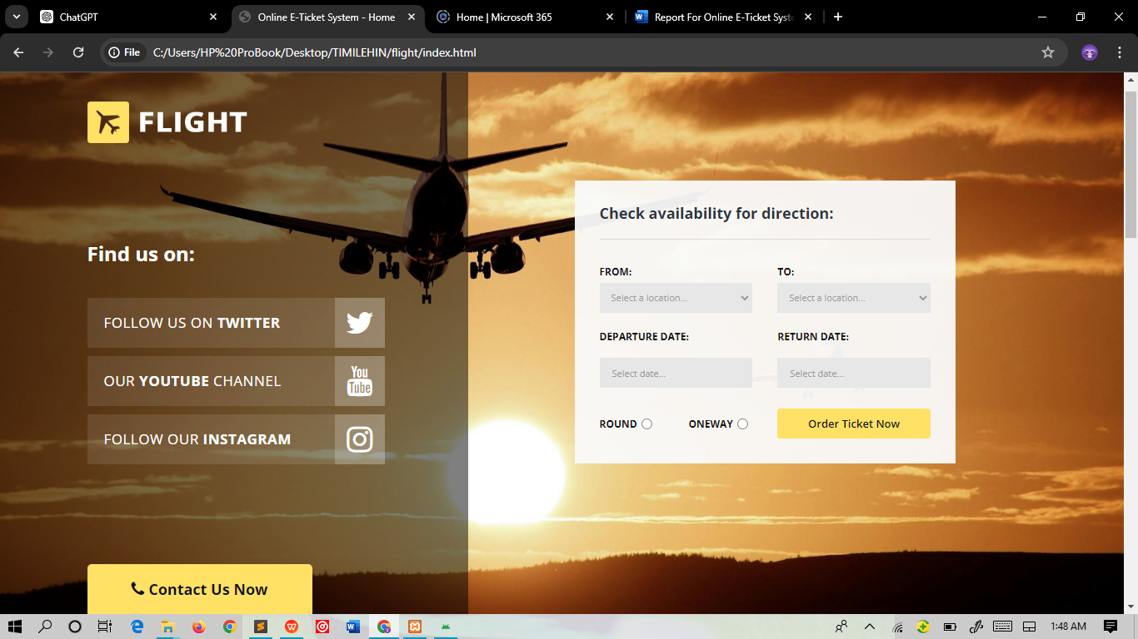

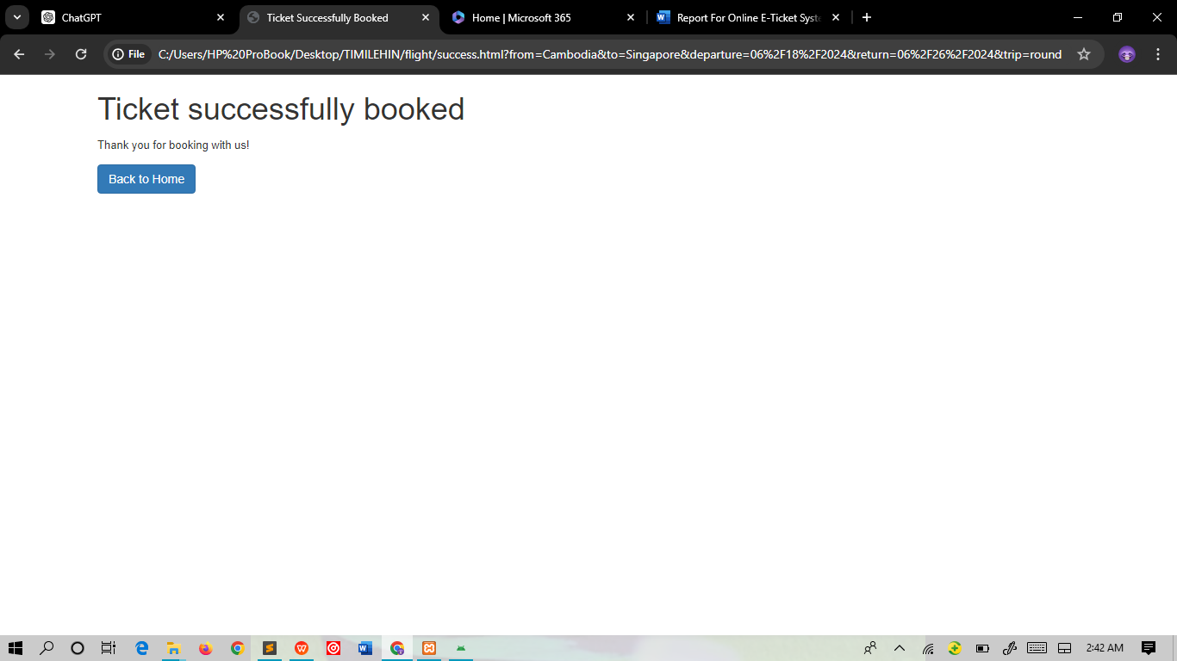

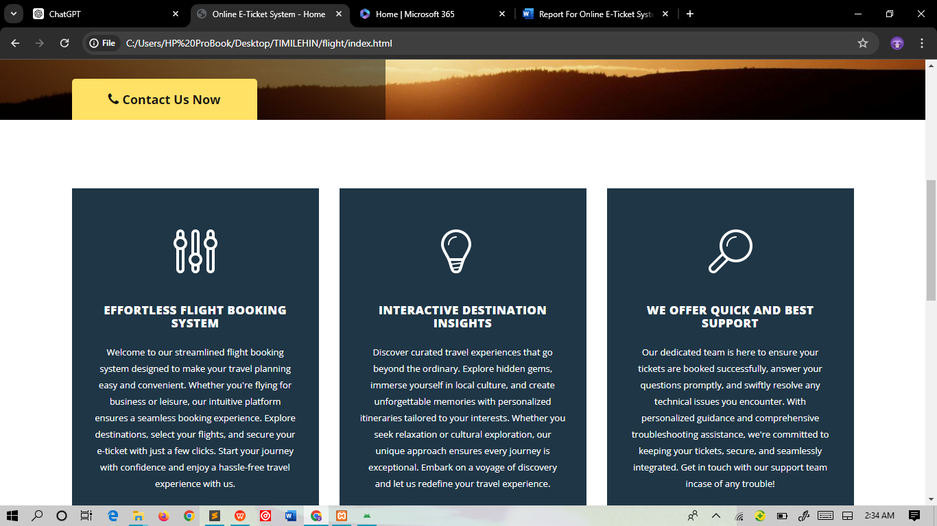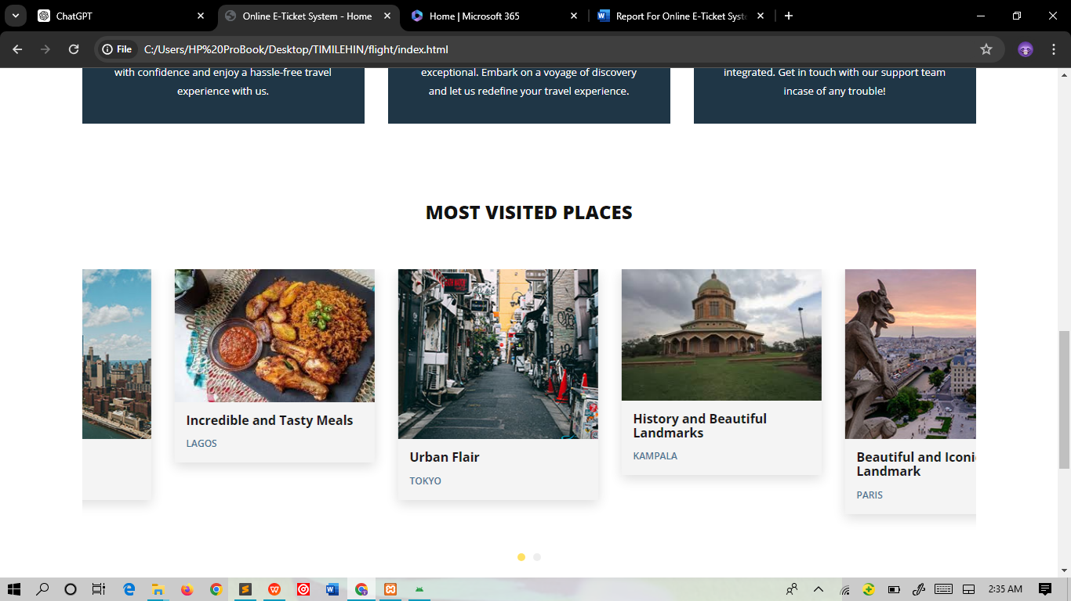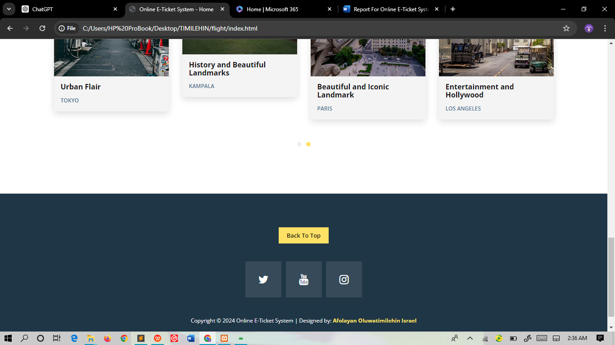

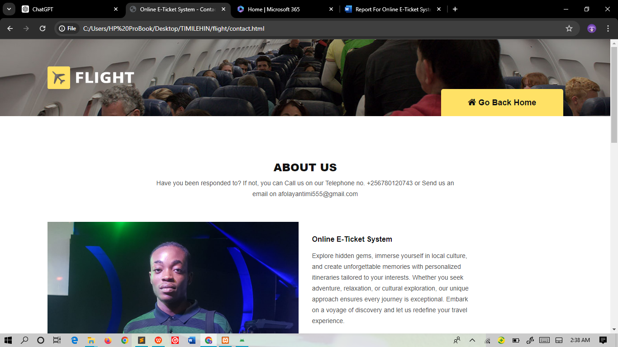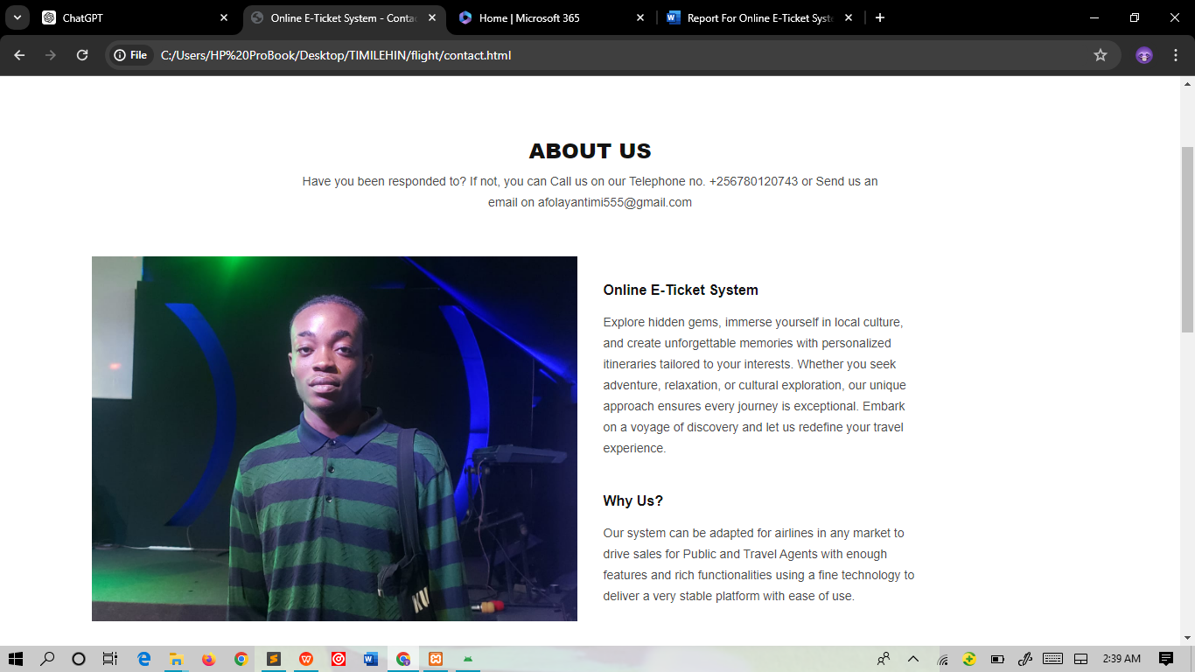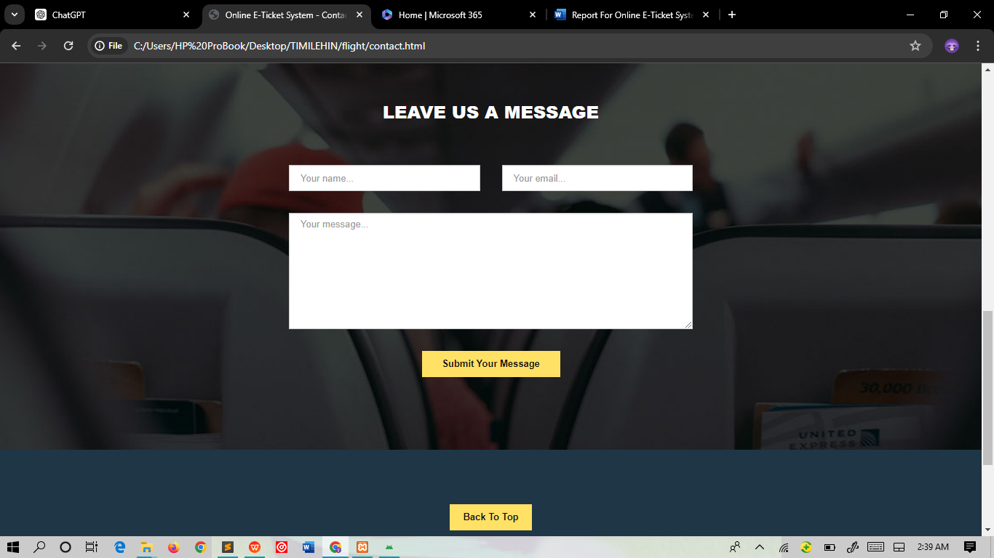

**Recommendations and future designs**

While the Online E-Ticket System showcases a robust and user-friendly front-end design, there are several recommendations to further enhance its functionality and usability:

1. **Back-End Development:**
   * **Database Integration:** Implement a back-end system using a relational database (e.g., MySQL, PostgreSQL) to store user data, booking history, and flight information.
   * **API Integration:** Integrate with third-party APIs for real-time flight data, pricing, and availability. Additionally, secure payment gateway APIs should be incorporated for transaction processing.
2. **User Authentication:**
   * **Login/Registration System:** Develop a secure login and registration system to manage user accounts, ensuring that users can save their booking history and preferences.
   * **Password Management:** Implement password encryption and recovery mechanisms to enhance security.
3. **Enhanced User Experience:**
   * **Personalized Recommendations:** Use user data to provide personalized flight recommendations and offers.
   * **Multilingual Support:** Implement multilingual support to cater to a diverse user base, enhancing accessibility.
4. **Performance Optimization:**
   * **Load Time Reduction:** Optimize images and use lazy loading techniques to reduce page load times.
   * **Code Minification:** Minify CSS, JavaScript, and HTML files to improve site performance.
5. **Responsive Design:**
   * **Cross-Platform Compatibility:** Ensure the website is fully responsive across various devices and browsers, providing a seamless experience on mobile phones, tablets, and desktops.
6. **Testing and Quality Assurance:**
   * **Automated Testing:** Implement automated testing frameworks (e.g., Selenium, Cypress) to regularly test the website’s functionality and ensure reliability.
   * **User Testing:** Conduct user testing sessions to gather feedback and identify areas for improvement.

**Conclusion**

The Online E-Ticket System represents a significant step forward in simplifying the process of booking flight tickets. The front-end design, developed using HTML, CSS, and JavaScript, provides a clean, responsive, and intuitive user interface. The use of modern web development practices ensures that the system is both aesthetically pleasing and functional.

While the current project is focused on the front-end design, future enhancements should aim to integrate comprehensive back-end support, including database management, API integration, and secure user authentication. By implementing these recommendations, the system can evolve into a fully-featured, robust platform capable of handling all aspects of the flight booking process.

This project serves as a strong foundation for further development and demonstrates the potential for creating a seamless online booking experience. With continued improvements and the addition of advanced features, the Online E-Ticket System can become an indispensable tool for travelers and travel agencies alike, providing efficient, reliable, and personalized flight booking services.